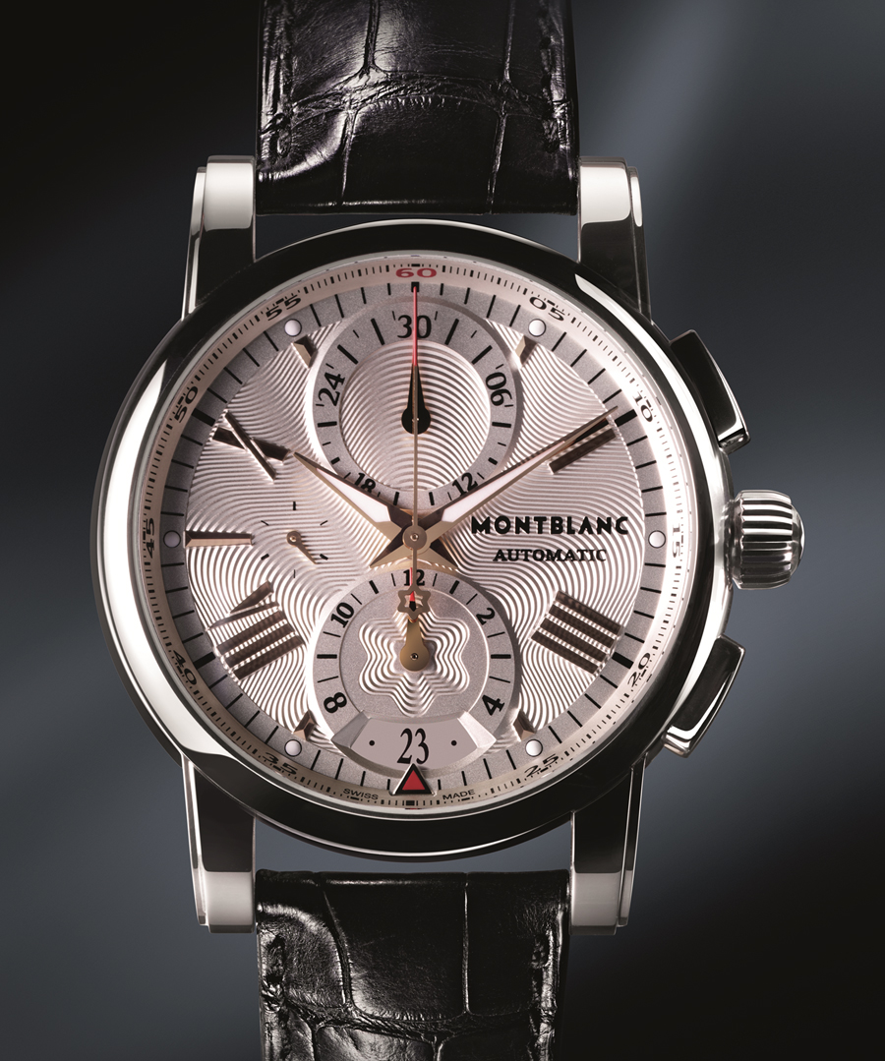MONTBLANC

DESCRIPTION: Montblanc is a prestigious luxury brand known for its fine writing instruments, leather goods, and Swiss-made timepieces. Founded in 1906 in Germany, Montblanc initially gained fame for its high-quality fountain pens before expanding into horology.

Montblanc watches are crafted in Switzerland, combining traditional craftsmanship with modern innovation. The brand’s most notable collections include the **1858**, inspired by vintage military watches; the **TimeWalker**, designed for motorsport enthusiasts; and the **Star Legacy**, which embodies classic elegance. With movements developed at Montblanc’s prestigious **Minerva** manufacture, the brand ensures exceptional precision and heritage in watchmaking.

Known for its sophisticated designs and commitment to excellence, Montblanc offers timepieces that symbolize refinement, innovation, and timeless style, making them a preferred choice for professionals and collectors alike